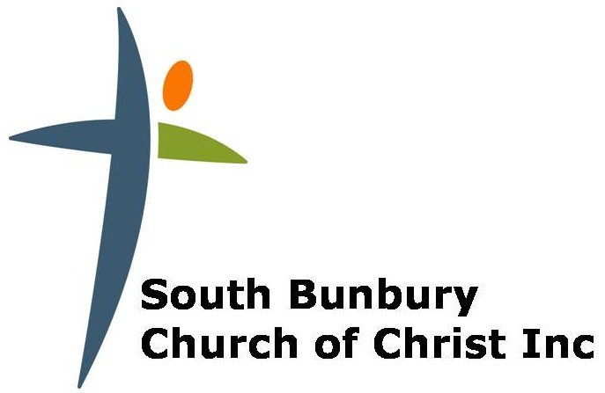

Statement of Faith

- We believe in one true perfect God in three persons, Father, Son and Holy Spirit.
Genesis 1:26-27, Deut. 6:4, Job 33:4, Isaiah 44:6, Is 45:5-6 , Jer. 10:10; Matthew 5:48, Matthew 28:19, John 5:19-20, 14:9-11, Romans 8:9-11, I Cor. 8:4-6, 1 Cor. 12:4-6, 2 Corinthians 13:14, 1 Thess 1:9, 1 Tim 2:5, Titus 2:13, Heb. 1:1-13

- God is the creator and sustainer of all things. Sovereign in creation, revelation, redemption and final judgement.
Gen 1, Deuteronomy 33:27,Psalm 89:26, Psalm 95:3( Only God), Isaiah 6:3, Romans 1:20, I Cor. 8:4-6, 2 Cor 6:18, 1 Tim 1:17, Heb 11:3, James 1:16-18, 1 John 3:1

- The Lord Jesus Christ is God’s incarnate Son. As both fully God and fully man, He willingly obeyed His Father’s will to leave His glory and come to earth to redeem His people for His Eternal Kingdom. He accomplished this through His sacrificial death and His resurrection from the grave.

Job 19:25 (My redeemer lives), Is 7:14, Is 9:6, Matthew 27:51, Matthew 28:1-10 (story of resurrection), Luke 1:35, 23:46 (Jesus gave up His spirit), Mark 13:32-33, Mark 16:19, John 1:1-14, John 5:17-18, 22-23, John 10:30, 1 Corinthians 15:3-15 (our hope in His resurrection) ,55 (Jesus defeated sin & death), Colossians 1:15-23, 1 Tim 2:5 (Mediator), Hebrews 1:8

- The Holy Spirit lives within each saved believer, convicting them of sin, righteousness and judgement. They are transformed by His truth, receiving power to be His witnesses to the world and for the benefit of His Church.

Psalm 139:7-8 (He is everywhere), Job 33:4( He is God and was there at creation), Matthew 12:28 (Spirit gives power to even drive out demons),John 14:16-17 (Lives with and in us, Spirit of Truth); 26 (Teach and remind us of what Jesus has said); 16:8-15 (Convicts the world of sin, righteousness and judgement, Acts 1:8 (we receive power from the Spirit to be His witnesses), Romans 8:9;26, 15:18-19, 1 Cor 6:11 (Sanctified & Justified in the name of Jesus by the Spirit- Transforms), 1 Cor. 12:4-7, 14:12 (Provides us with His Gifts for the growth of the Church) ,2 Cor 1:21-22 (Guarantee of what is to come) 3:17( He represents freedom for sinners), Gal 5:22-23 (Helps us lead a fruitful life), Ephesians 1:13-14 (Guarantee of what is to come)

- The Bible is the living and active Word of God. It is to be used for teaching, rebuking, correcting and training in righteousness, to equip believers for service.
2 Tim 3:15-17, 2 Peter 1:20-21, Heb 4:12

- In the beginning God created humanity in His perfect image, holy and blameless. Through sinful rebellion we separated ourselves from God. The penalty of which is eternal death apart from Him.
Genesis 1:26-27, Romans 3:23, 5:12, 6:23

- We are unable to save ourselves from the penalty of our sin and in this state we are separated from God. The Father sent His Son to reconcile us to Himself through Jesus death. Therefore salvation is by God’s grace alone. Those who truly believe by faith and repent of their sinful life will be regenerated by the Holy Spirit. We are led by Him to become children of God.
Matthew 16:21-26, Mark 10:45, John 3:3-5, 16-19, John 14:6, Acts 4:12, Rom 3:24-25, Romans 5:1;21,Rom 6:23, Rom 10:8-13, Colossians 1:15-23, 2:13, Eph 2:8-9, Titus 3:5, I John 5:9-12

- The Church as the body of Christ is made up of all who acknowledge Jesus Christ as Lord and Saviour. As the head of His Church, Jesus calls us to be His witnesses and to make disciples of all nations. We do this for His glory and to reflect His character.
Acts 2:42-47, Romans 12:3-5, 1 Cor 12:12-26, Eph 2:19-22, Eph 5:25-27, Col 1:17-20; 3:14-16, 1 Peter 2:9-10

- The Lord Jesus Christ will return in person, at a time of the Father’s choosing to execute God’s just condemnation on those who have not repented and to receive the redeemed to eternal glory.
Matt 24:27-51, Matt 25:1-13, 1 Thess 4:14-18, 1 Cor 15:24-28, Titus 2:13, Rev 1:7, Rev 19:11-20:15, Rev 21-22

- We believe in and practise Baptism by full immersion.
Matthew 28:19, Acts 2:38, Galatians 3:27, Romans 6:3

